 | REPAIR FORM
Dive shop or
Customer name
Address
Postal code |  |  | Town
GSM |  |  | E-mail
Name/type suit
PRIO €50 | YEES / NO
Wrist | cm | Neck |  |  | cm | Shoe size
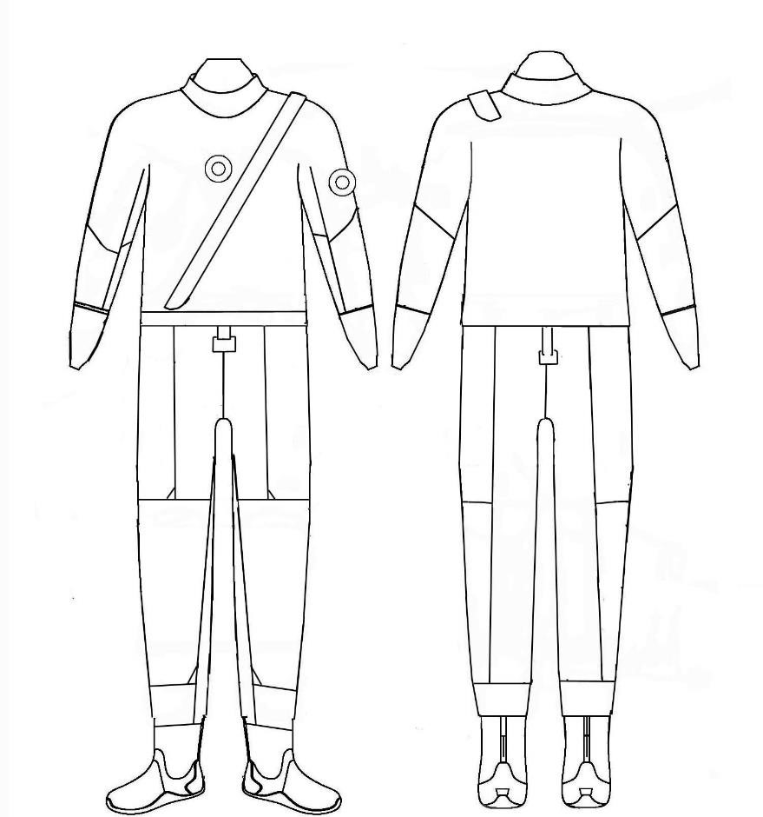 |  |  |  |  | Description repairs:

Scubarepair.Be – Corbeillestraat 86 blok D 2235 Westmeerbeek – Tel 0495/18.22.77 – info@scubarepair.be
Btw : BE 0670.846.951

